

Practices for Secure Software Report

Table of Contents
Document Revision History 3
Client 3
Instructions 3
Developer 4
1. Algorithm Cipher 4
2. Certificate Generation 4
3. Deploy Cipher 4
4. Secure Communications 4
5. Secondary Testing 4
6. Functional Testing 4
7. Summary 4
8. Industry Standard Best Practices 4

Document Revision History

Version | Date | Author | Comments
1.0 | 10/25/2025 | Travis LeBlanc | Provided descriptions for each section as well as supporting screenshots

Client



Instructions

Submit this completed practices for secure software report. Replace the bracketed text with the relevant information. You must document your process for writing secure communications and refactoring code that complies with software security testing protocols.

- Respond to the steps outlined below and include your findings.
- Respond using your own words. You may also choose to include images or supporting materials. If you include them, make certain to insert them in all the relevant locations in the document.
- Refer to the Project Two Guidelines and Rubric for more detailed instructions about each section of the template.

Developer
Travis LeBlanc

Algorithm Cipher

For this project, I recommend the use of the SHA-256 hashing algorithm for data integrity verification, and AES-256 encryption for any future secure data storage or transmission needs.
High-Level Overview
SHA-256 is a cryptographic hash function that produces a fixed-length 256-bit output from any input. It is deterministic, collision-resistant, and irreversible — ideal for verifying data integrity. AES-256 is a symmetric encryption algorithm used to securely encrypt and decrypt data using the same key.
Hash Functions and Bit Levels
SHA-256 generates a 256-bit hash value, typically shown as a 64-character hexadecimal string. It belongs to the SHA-2 family, which includes variants like SHA-224, SHA-384, and SHA-512. The higher bit level provides stronger resistance to brute-force and collision attacks.
Randomness and Key Types
SHA-256 does not use keys but can be paired with random salts for added protection. AES-256 uses symmetric keys, meaning the same key is used for encryption and decryption. Asymmetric encryption (e.g., RSA) uses public/private key pairs and is ideal for secure key exchange.
History and Current State
SHA-256 was published by NIST in 2001 to replace the vulnerable SHA-1. AES-256 was standardized the same year after a global competition and replaced DES. Both algorithms are widely adopted in modern security protocols, including TLS/SSL, blockchain, and secure APIs.
Justification
Given the vulnerabilities addressed — plaintext transmission and data tampering — SHA-256 is ideal for checksum verification. AES-256 is recommended for future encryption needs. Both are supported by Java’s security libraries and align with OWASP and NIST standards.

Certificate Generation
Insert a screenshot below of the CER file.

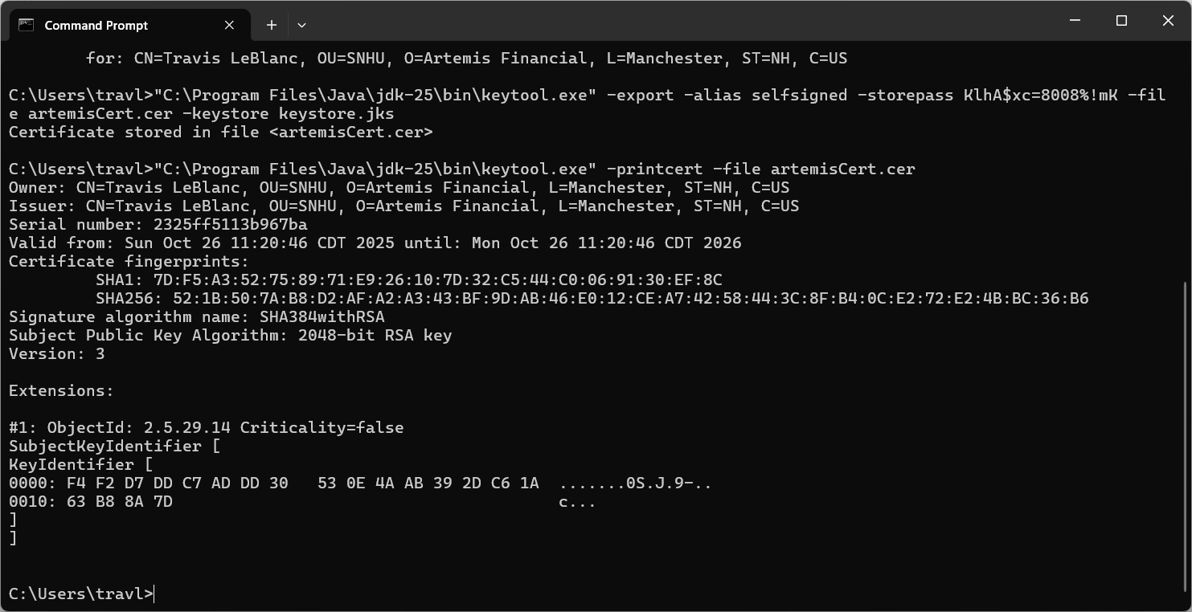

Deploy Cipher
Insert a screenshot below of the checksum verification.

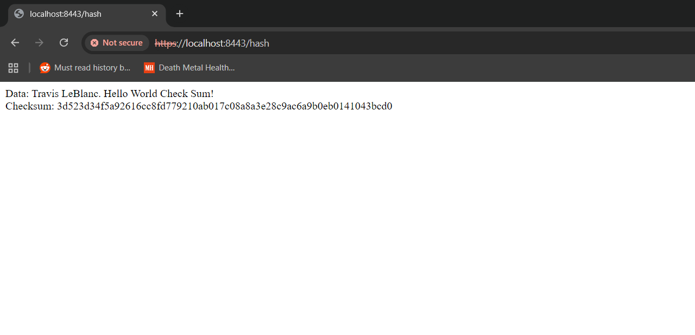

Secure Communications
Insert a screenshot below of the web browser that shows a secure webpage.



Secondary Testing
Insert screenshots below of the refactored code executed without errors and the dependency-check report.

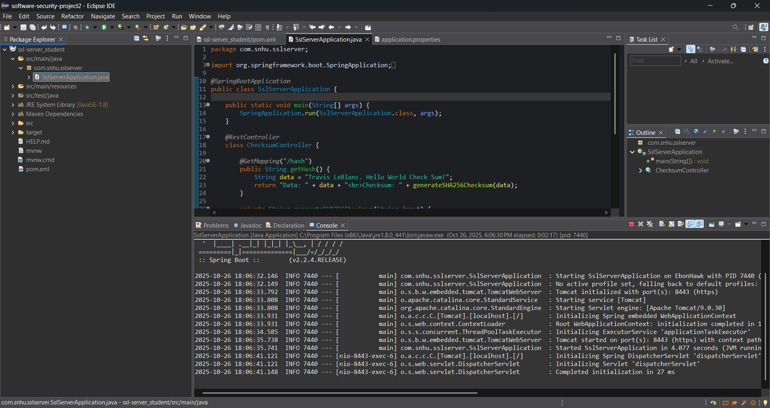

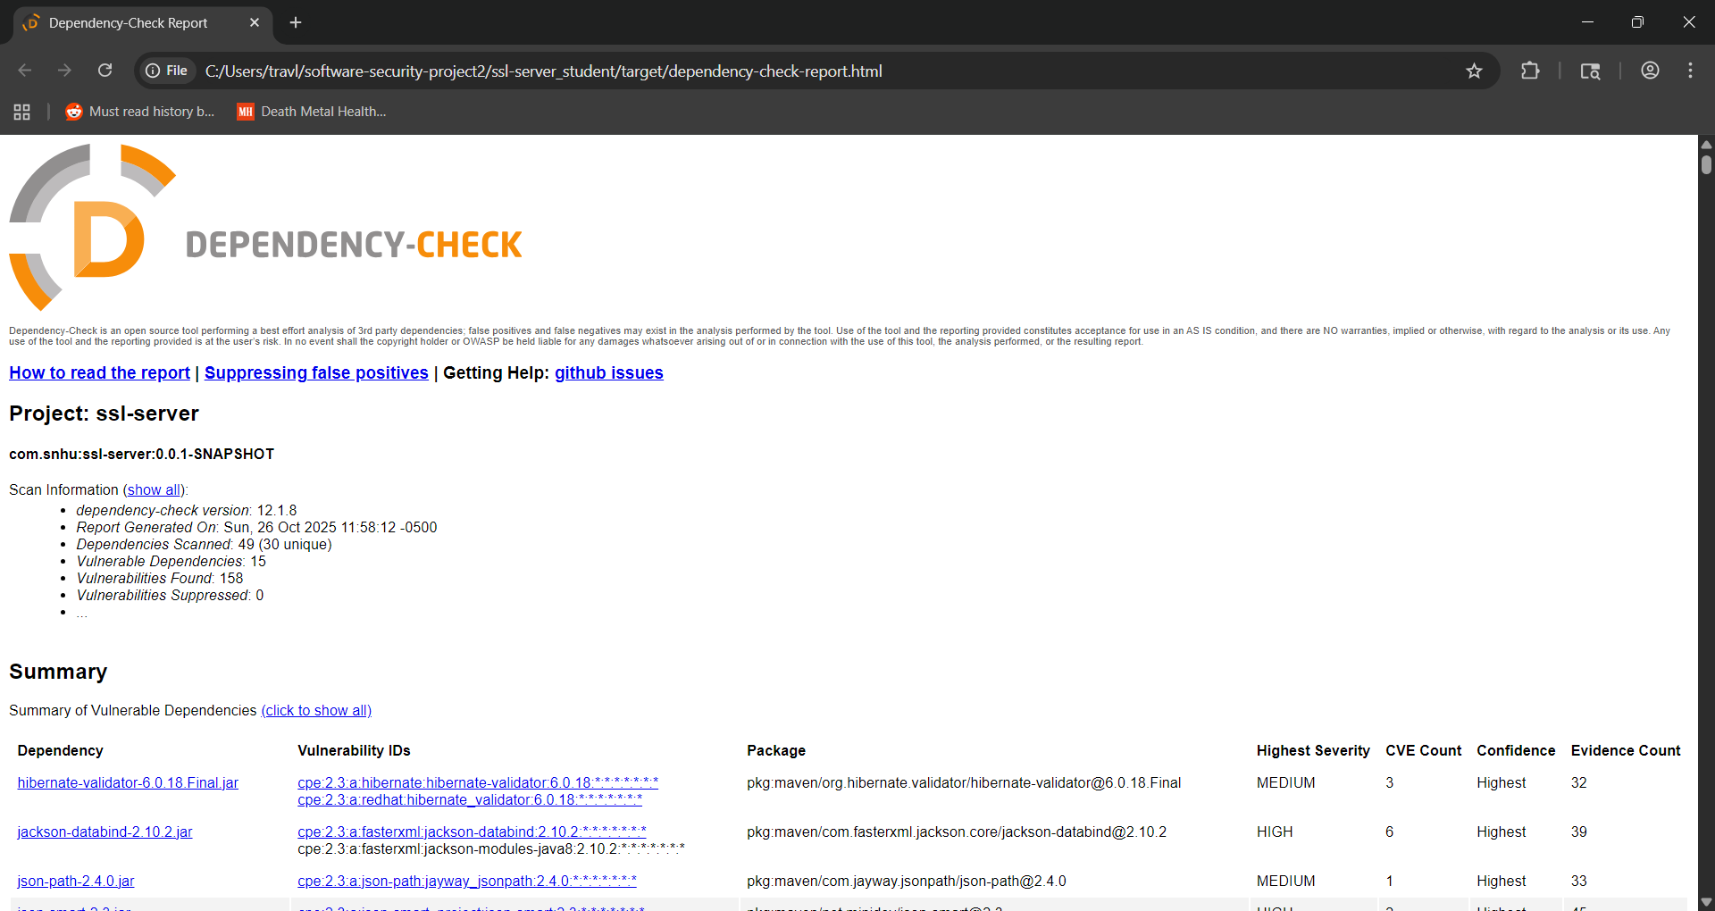

Functional Testing
Insert a screenshot below of the refactored code executed without errors.



Summary

The code was refactored to comply with secure software development practices by converting HTTP to HTTPS and implementing a checksum endpoint. Vulnerabilities addressed include plaintext transmission and data tampering. Security layers added include SSL encryption, SHA-256 hashing, exception handling, and static analysis. These changes align with the vulnerability assessment process flow, covering design, implementation, and testing phases.

Industry Standard Best Practices

Industry standard best practices were applied throughout the project to mitigate known vulnerabilities and maintain the application’s security posture.
Maintaining Existing Security
- HTTPS was enforced using Spring Boot’s native SSL support
- SHA-256 was used for secure, collision-resistant hashing
- No hardcoded secrets or insecure algorithms were introduced
- Static analysis validated the code’s safety
- Exception handling was implemented to prevent silent failures
Value to the Company
Applying secure coding practices ensures long-term maintainability, protects user data, and reduces the risk of breaches or compliance violations. It builds trust with users and stakeholders, aligns with OWASP and NIST standards, and demonstrates that secure refactoring is achievable without sacrificing functionality. These practices contribute directly to the company’s operational resilience and reputation.

